[1,1] A = 0
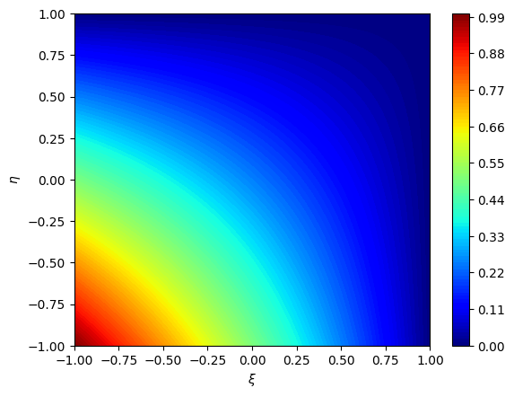
[2,1] A = 1
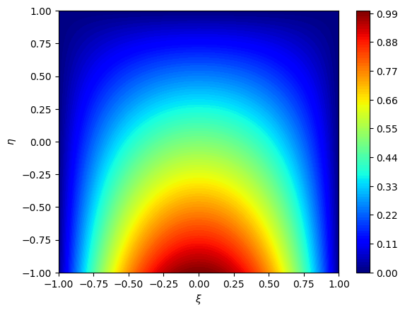

[2,2] A = 4
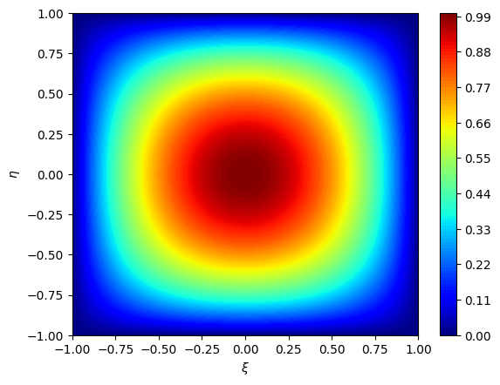
[3,3] A = 5
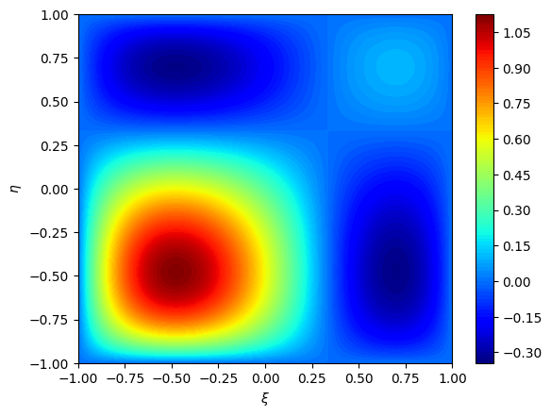

p = 1, {xa} = {0, 1}, {ξa} = {−1, 1}
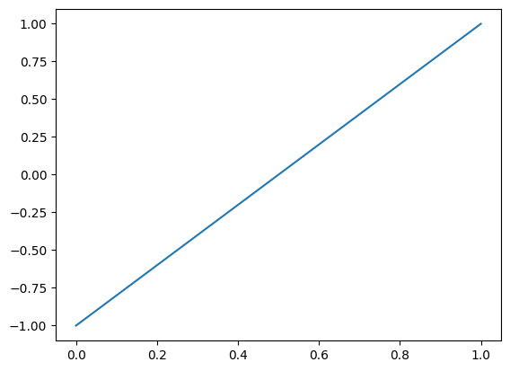
p = 2, {xa} = {0.5, 1, 1.5}, {ξa} = {−1, 0, 1}
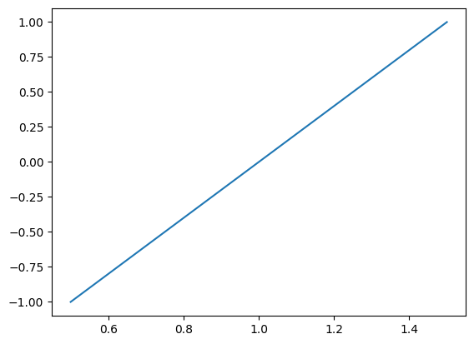

p = 2, {xa} = {0.5, 0.7, 1.5}, {ξa} = {−1, −0.6, 1}
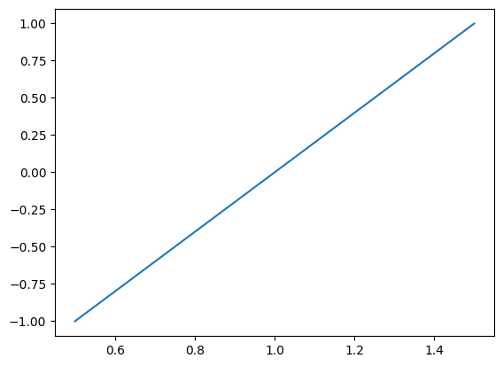
p = 2, {xa} = {0.5, 0.7, 1.5}, {ξa} = {−1, 0, 1}
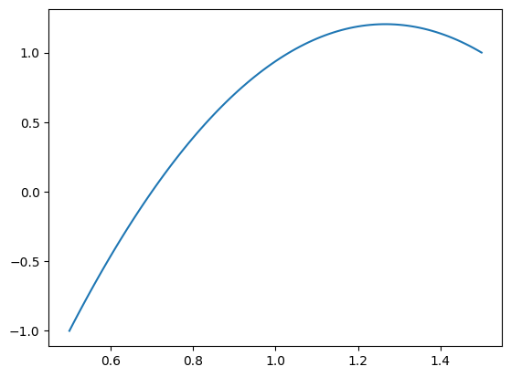
It is linear for the first one, where we have a degree of 1 and everything is nicely spread out for the spatial points. Generally, to get accurate mapping, we should choose spatial points that are evenly spaced.

